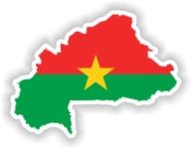
Dear Brothers and Sisters, March, 2024

When we look back on the last 23+ years, we are amazed at all the Lord has done. We could cite numbers such as hundreds of nonbelievers coming to Christ every year, many young people who are educated and employable, but we also like to learn about their individual stories.
Jeanine started school from the beginning of our first school. When her father died from AIDS, Jeanine, her mother, her baby brother, and her younger sister all moved into the brand new Bethesda Home for widows and orphans.
When Jeanine finished secondary school, she stayed with her family in the Bethesda Home, but she started university. She finished with a degree in economics and is now working at the secondary school in Bobo-Dioulasso.
The story wouldn’t be complete without Jeanine finding the love of her life,
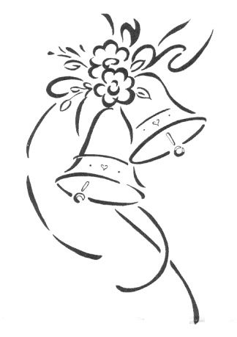
a born-again Christian young man. They will be married April 13!
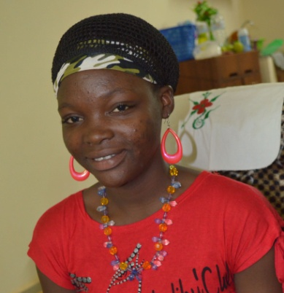
Jeanine’s baby brother is now in 11th grade and although her sister is HIV positive, she has been able to finish secondary school.

We still need more child sponsors. Sponsors have a special responsibility to pray for the children they sponsor. Pray that they will receive Jesus Christ as their Savior and grow spiritually. Pray for their classroom studies. Pray for their families. Child sponsorship starts with the youngest children, but if you continue in your sponsorship, you will likely see them either learn a craft or be an apprentice, or go on to university.
www.wacm.info
Upcoming Events:
- March 4-6 will be a seminar on evangelism in the village of Baré. Most of the participants are not educated, so the material will be presented in the Jula language.
- March 6-11 will be the annual convention for the churches of the cities of Bobo and Dedougou, held in the village of Baré. Pray for good participation and encouragement.
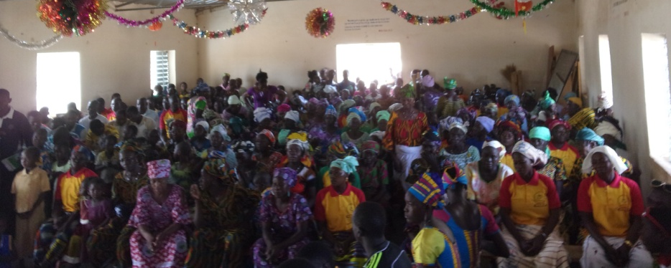
- March 22-30 will be a national week of prayer and fasting for all the churches of Burkina Faso. There is much need, so let’s pray with them.
Thank you for your faithful prayers and support. God Bless YOU!
~ Judy Hull reporting for Dr. Moussa Coulibaly

Donations can be received at:
West African Christian Ministries
P.O. Box 429
Valparaiso, Indiana. 46385

